# Notes Meeting 28-2-2017 about review archetypes/templates by Hildegard

## Regarding General Template:

Hildegard is fully right here. Versioning the archetype was a wrong decision, and it is better to use the original archetype, and constraint it in the template.

## Regarding Virology Template:

We are not sure if it is better to use a generic virology archetype and clone it in the template or use specialized archetypes which only another identifier. We agree that one (generic) archetype is better to maintain then a series of (similar) archetypes. But maybe there are disadvantages we want to discuss with Hildegard.

One problem with the generic archetype situation is that the cloned archetypes all contain the same data(ADL)-paths and that it therefore will be difficult in AQL to distinguish them. We have the same question on other clone-situations (for example left/right kidney which use the same kidney archetype and for example, a group of very similar lab-test-archetypes). This is a very important modeling related question.

I have investigated the problem in ThinkEHR and we see that the cloned archetypes have exact the same ADL-paths (as expected)

**freshEHR Comments:**

**We think the path issue is now understood, and that using a single generic archetype or clones of archetypes has no negative impact on querying.**

Another point is the terminology-binding. We cannot use terminology binding in the archetype if we use a generic archetype. Terminology binding is a very important objective for Eurotransplant and healthcare ICT in general.

So we are very interested in the opinions of Hildegard, regarding this.

**freshEHR Comments about terminology usage in openEHR**:

1. **Defining codes**

* **Using a ‘double colon string’ in the name field allows to define left hand side of the name/value pair inside the template. This is carried in the OPT file and should be used at runtime by Think!EHR to create a Coded_text name not just simple text – we are awaiting confirmation form Marand that this correct.**

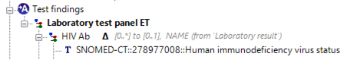

* **The same ‘double colon string’ method can also be used to define default instance values where appropriate (note below is just an illustration, default value probably not appropriate in this case). Again, we are checking with Marand that this behaves as expected.**

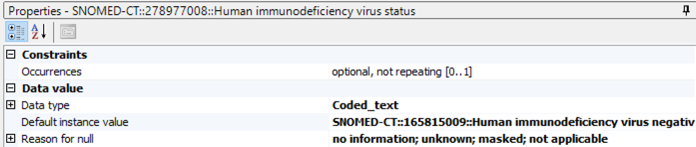

* **It should be possible to define codes for the right-hand side valuesets, but the current template designer does not support this.**

1. **Mappings**

* **Mappings from internal codes to other terminologies (SNOMED CT, LOINC, local terminologies) must be done at runtime, there is no automatic mapping process in openEHR.**

1. **Bindings**

* **Bindings are recommendations for mappings only, there is no automatic creation of mappings from bindings added either in archetypes or templates. There are currently some discussions in the international community to implement some automatic mapping wherever bindings are found, but this needs further community discussion since this would carry some risks as well.**
* **The best way to add bindings at the template layer is by using the Annotations function with this format: *Terminology::Code::Description;Terminology::Code::Description* as illustrated in the screenshot below**

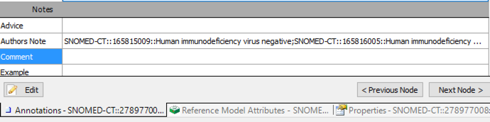

## Regarding Virology Template:

We got initially confused by the purpose of the immunisation summary archetype. This archetype seems to be focused on the vaccination-process, while the purpose indicates that it describes the vaccination-status.

Hildegard was right that the use of “not commenced” was not very well explained, and the purpose of using it was to mask the missing of a data-item which we needed.

We solved it in following way, and want to discuss this solution with Hildegard: We only use the “Immunisation Summary”-archetype, and use only the “Infectious Disease or Agent”, which we called for our need: “Hepatitis B immunized”, and use the “yes/no”-list of values, and use the Null Value Flavour to replace the “not commenced”. We are not sure to use the “Unknown” or the “No information” null value flavor.

We like to discuss this with Hildegard.

**freshEHR Comments:**

**Having discussed this in some more detail, our recommendation would be to use the Immunisation Summary and the Specific vaccine cluster inside that archetype. The required fields to expose in the template would be**

* **Infectious Disease or Agent renamed to Hepatitis B**
* **Primary Course Status where your *Yes* value corresponds to *Complete*, your *No* value corresponds to either *Not commenced* or *Incomplete* and your *Unknown* (Not commenced) value corresponds to *Indeterminate*.**

**All other fields should be set to zero instance.**

## Regarding Abdominal Template: One big observation/more observations.

It is on the Eurotransplant-site not recognizable if it is (technical) one Observation or more Observations involved in gathering the information about the Abdomen-organs. There is some data-information which suggest it is one Observation. This is the fact that “en groupe” only one device is known for the abdomen examination.

But we also recognize the fact that it may be from modeling-point of view to use more Observations, although it may be a (technical) single or few (maybe less then organs) Observations.

We like to hear the opinion of Hildegard on this.

**freshEHR Comments:**

**This template is definitely about Imaging results, not about physical examinations, but there are a number of different scenarios which would result in this being modelled differently:**

1. **There is a single summarized report which contains information from more than one imaging modalities (MRI, CT or Ultrasound) about multiple organs.**

**For this scenario, we would recommend creating a new ‘imaging summary’ observation archetype, which contains minimal data points from the international; ‘imaging examination’ observation, but with the important distinction of MULTIPLE modalities. The detailed information for each organ would be plugged into the ‘Result’ slot in that archetype (using the ‘Exam liver, Exam Pancreas etc clusters), and the template would contain just a single instance of that archetype.**

**We have created such an archetype and can share it if you choose to go this way. We would also envisage taking this idea to the international community for consideration.**

1. **There are separate summarized reports for each organ, but contains information from more than one imaging modality.**

**For this scenario, we would use the same ‘imaging summary’ observation, but have multiple instances of the observation archetype (one for each organ) with the result slot filled with a single cluster for that organ.**

1. **There is a single report from a single modality containing information about multiple organs.**

**This is likely to be closest to the original imaging report where normally a request for imaging would be for a single modality e.g Ultrasound, but might well report on several organs. For this scenario, we would use the existing ‘imaging examination’ observation (currently with the UK specialization, but this will become the international version). This allows for a single modality and multiple result clusters in the ‘Result’ slot. The template would contain a single instance of the imaging examination observation, with all the organ results in the ‘Result’ slot.**

1. **There are separate reports from a single modality containing information about a single organ.**

**For this scenario, we would again use the existing ‘Imaging examination’, but this time have a separate instance of that observation archetype (one for each organ) and a single result cluster for that organ in the ‘Result’ slot.**

**One consideration whether to choose single or multiple (1. versus 2. and 3. versus 4.) would be whether the different organ examinations were done on different dates or by different examiners, since both these attributes apply to the observation as a whole, so 1. and 3. would not allow for different dates or examiners. 3. Is most likely to align with the original imaging report with a single modality and one or more organs.**

## Regarding Abdominal Template: Imaging result Observation

While studying this issue, we found a specialization written by Grahame Grieve. It is called: “Imaging examination result UK”. It offers the data-items (in slots) we were missing, like Result Details and the anatomical-site cluster. So this complies to the data-requirements. We like to restructure the Abdomen (and other sets) to this archetype.

The remarks in the review about “Body Part examination”, Body examination panel” are then no longer relevant anymore.

We are very interested in the opinions of Hildegard, regarding this

**See above comment which addresses this as well.**

## Regarding Abdominal Template: Examination Details Cluster

The Reference Model Composition contains a “composer” and Observation contains a “provider”.

However, those both data-points are not for us to model, because the archetype-editor nor the template-editor offers this. These items are filled by the software, and we guess, it is the one who is logged in, who will be entered in the software, and also the date/time of entering will be stored.

Mostly this is not the data-provider (in our case), mostly the data are provided from a remote site and on a previous time. We want to store this information.

**freshEHR Comments:**

**We suggest using the Reference Model ENTRY.provider attribute for the Examiner and the Reference Model OBSERVATION.origin attribute for the date of examination/imaging.**

**Both are associated with the Observation, and they can be exposed in Template Designer by displaying the Reference Model attributes pane:**

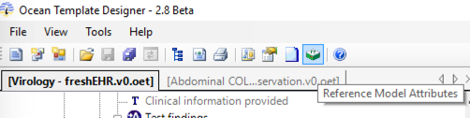

**‘Provider’ sits at the top level of the archetype, and to expose it highlight the archetype name on the left of Template Designer and clicking the box next to Provider on the right. The name of that attribute can then also be changed.**

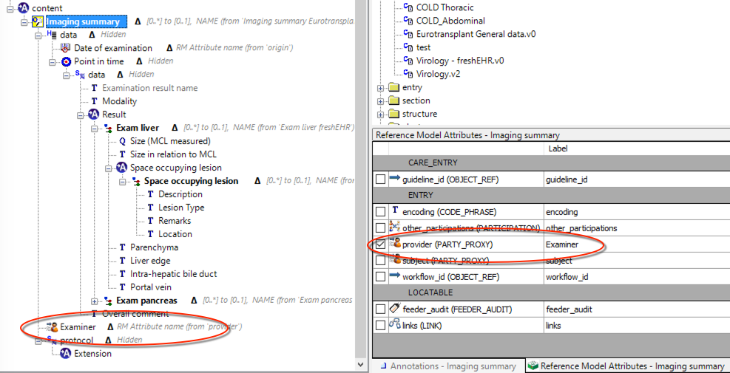

**‘Origin’ sits at the data level (just below the archetype name), and again just ticking the box will display it on the left hand side of Template Designer.**

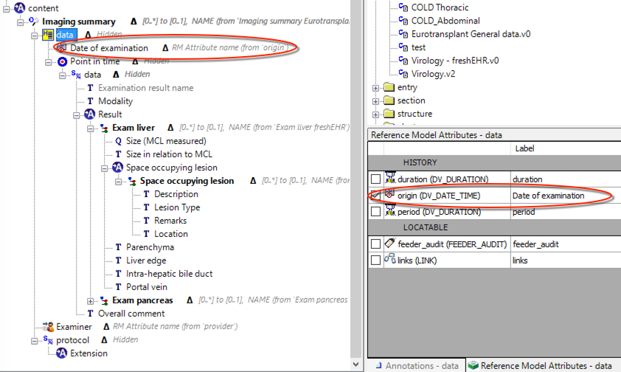

**This is an example of a FLAT JSON instance, carrying these attributes for a report carrying 2 Imaging Observations, one for MRI and one for U/S, each with a composer (the person creating the curated composition about the donor), and a different provider / origin for each Imaging investigation.   
  
TBD**

## Regarding Abdominal Template: ‘examination of the abdomen specialisation’-redundancy

The answer is in relation to the problem described in one or more observations.

**Resolved**

## Regarding Abdominal Template: Status data point in all clusters.

This is regarding the “space occupying lesion”. Because of the different semantic meaning of “not investigated” opposed to “not assessable/yes/no”, it is desired to store this separately. “not investigated” indicates information about the status of a examination, and “not assessable/yes/no” are about the result of an examination.

**freshEHR Comments**

**Agree totally about semantic differences, but modelling this in a pure semantic fashion would make the implementation hugely more complex.**

**We feel very comfortable with ‘breaking our own rules’ about mixing paradigms for this situation, and add the ‘not investigated’ value to the examination result valueset.**

## Regarding Abdominal Template: “(space occupying lesion) a choice of text and coded text  rather than two separate data points”

The free text field is not to replace the list-of-values, but is additional. To make this more clear, we will rename it to “remark”.

**freshEHR Comments**

**As discussed, using ‘choice’ for data types does not mean that only one of these choices can then be implemented. The most commonly used case for this is where a picklist in the UI also contains an option for ‘Other’ which then needs to be filled with free text, and in this instance both choices would remain available in the implementation.**

**However, we understand that this is not what’s required here, and therefore using a Coded Text type for the picklist and a separate Text type for the comment/remark is the correct approach.**